Finding the Optimal Restaurant Location

# Introduction

Fiona comes from a family of chefs. Since moving to the Toronto, she is looking for opportunities to open her own Chinese restaurant to carry on the family tradition. However, she cannot decide the exact location for her business. She knows that she wanted to open the restaurants in the Scarborough area, as there are a lot of Asian immigrants in that borough. There have already been many Chinese restaurants in the area but she is not afraid of the competition. In fact, she intends to use the traffic to her benefit. Her cuisine is unique and she is proud of her skills. She is confident that her cooking will stand out once the business is established. As a result, she intends to place her restaurant in a place with the densest profile of Chinese restaurants.

# Data

The Wikipedia will provide a table of postal codes that correlates to the name of the borough and the neighborhood. The table covers the Toronto area and its vicinity. Sometimes more than one neighborhood can exist in one postal code area. In those cases, the neighborhoods will be combined into one row with the neighborhoods separated with a comma. If a cell has a borough but not an assigned neighborhood, then the neighborhood will be the same as the borough.

Latitude and longitude data are retrieved online and merged with the table from Wikipedia. The resulting table will contain postal code, borough, neighborhood, latitude, and longitude. The final table will be restricted to only the Scarborough area by selecting boroughs that has the name containing the word "Scarborough". Any postal codes without a specified borough will be excluded.

The Foursquare location data will be used to help Fiona with her research. The Foursquare location data will provide venue information within a defined radius from Congress. The data will also be used to assess neighborhood characteristics to help Fiona decide which neighborhood should be the home of her restaurant.

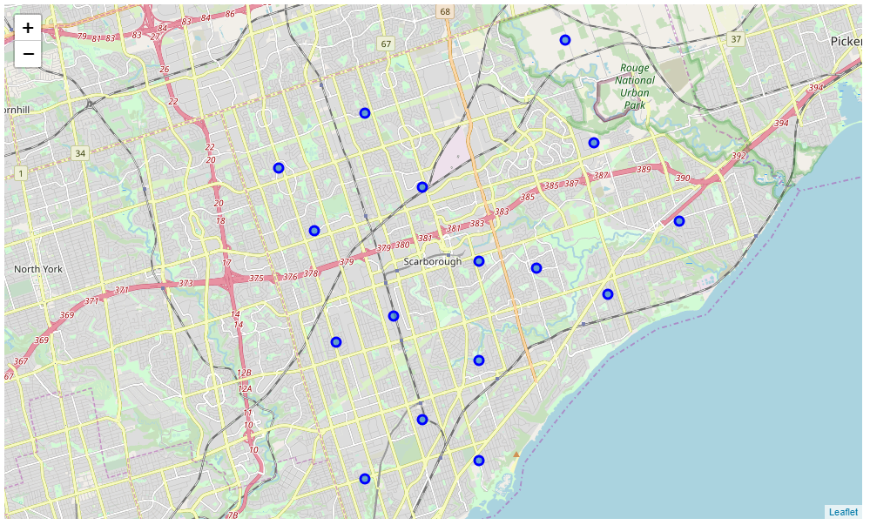

# Methodology

* We'll explore the Scarborough area and look for potential neighborhoods for Fiona to open her restaurant. Candidates will be identified if one of the top five common venues in the neighborhood is Chinese restaurant. We also noticed in the process that Upper Rouge has nothing within the 500-meter radius of its center. Therefore, Upper Rouge is removed from the data table.
* The search will focus in a 500-meter-radius circle from the center of the area.
* After we have narrowed down to several areas, we will search each area with the keyword “Chinese restaurant” and check how many Chinese restaurants there are in the area.

# Results

* The result shows that 3 postal code areas fit our selection criteria, namely M1P, M1V nad M1W. Additionally, the M1X area appears to not having any business in the area.
* Detailed searches show that the M1P, M1V, and M1W area actually have 2, 7, and 12 Chinese restaurants.

# Discussion & Conclusion

Our exploration of the Scarborough borough revealed three potential postal code areas for Fiona to open her restaurant in. However, we recognize that on websites such as Foursquare, one doesn't necessarily only receive results related to the search keyword. There are results returned that are deemed appropriate by the algorithm but are irrelevant from human perspective. As a result, we also performed detailed search of Chinese restaurant on the three area candidate. The result shows that if Fiona wants to benefit from the traffic generated by the currently existing restaurants, then she should find a place in the M1W postal code area.